🔷 Logic Gate (A to Z)
Logic gates are the basic building blocks of digital electronics and computers.
They work using Binary Numbers:
- 0 = OFF / False
- 1 = ON / True
Logic gates take input signals and produce output according to logical rules.

🧠 Types of Logic Gates
There are mainly 7 basic logic gates:
- AND Gate
- OR Gate
- NOT Gate
- NAND Gate
- NOR Gate
- XOR Gate
- XNOR Gate

1️. AND Gate

📘 Definition
AND gate gives output 1 only when all inputs are 1.

🔹 Boolean Expression
Y = A . B
📋 Truth Table (Y=A . B)
A | B | Y
0 | 0 | 0
0 | 1 | 0
1 | 0 | 0
1 | 1 | 1

🧾 Real Life Example
A machine starts only when:
- Power ON
- Switch ON
Both conditions must be true.

2️. OR Gate

📘 Definition
OR gate gives output 1 if any input is 1.

🔹 Boolean Expression
Y = A + B
📋 Truth Table (Y=A+B)
A | B | Y
0 | 0 | 0
0 | 1 | 1
1 | 0 | 1
1 | 1 | 1

3️. NOT Gate

📘 Definition
NOT gate reverses the input.

🔹 Boolean Expression
Y = A̅

📋 Truth Table(Y = A̅)
A | Y
0 | 1
1 | 0

4️. NAND Gate

📘 Definition
NAND = NOT + AND
It gives opposite result of AND gate.

🔹 Boolean Expression
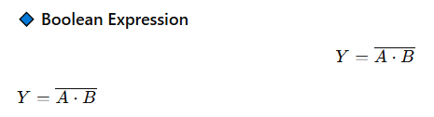

📋 Truth Table
A | B | Y
0 | 0 | 1
0 | 1 | 1
1 | 0 | 1
1 | 1 | 0
👉 NAND is called a Universal Gate because all gates can be made using NAND.

5️. NOR Gate

📘 Definition
NOR = NOT + OR
Opposite of OR gate.

🔹 Boolean Expression

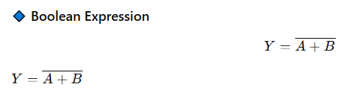

📋Truth Table
A | B | Y
0 | 0 | 1
0 | 1 | 0
1 | 0 | 0
1 | 1 | 0
👉 NOR is also a Universal Gate.

6️. XOR Gate

📘 Definition
XOR gives output 1 when inputs are different.

🔹 Boolean Expression
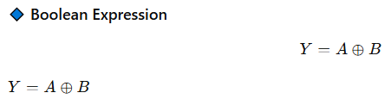

📋 Truth Table
A | B | Y
0 | 0 | 0
0 | 1 | 1
1 | 0 | 1
1 | 1 | 0

7️. XNOR Gate

📘 Definition
XNOR gives output 1 when inputs are same.
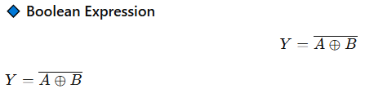

📋 Truth Table
A | B | Y
0 | 0 | 1
0 | 1 | 0
1 | 0 | 0
1 | 1 | 1

🔶 Universal Gates
Two gates are called universal:
- NAND Gate
- NOR Gate

Because they can create all other gates.
what is Universal gate and why called them universal?
What is a Universal Gate?
A Universal Gate is a logic gate that can be used to create all other logic gates.
This means using only one type of gate, we can build:
- AND gate
- OR gate
- NOT gate
- XOR gate
- XNOR gate
- Any digital circuit

✅ Which Gates are Universal Gates?
There are two universal gates:
- NAND Gate
- NOR Gate

🔶 Why Are They Called “Universal”?
They are called universal because they are capable of performing any logical operation.
Using only:
- NAND gates → we can build all gates
- NOR gates → we can also build all gates
So, they are “universal” for digital circuit design.
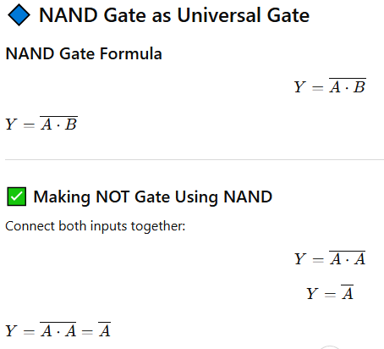
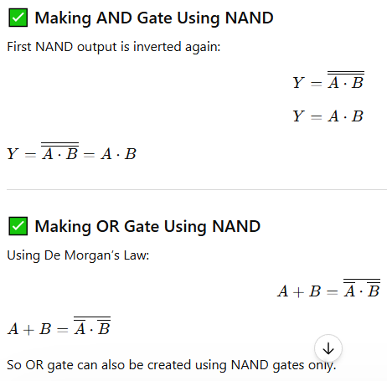
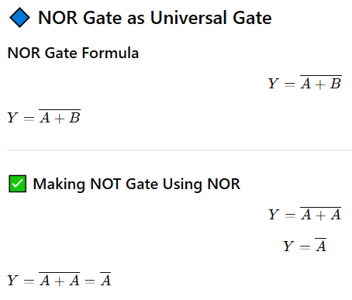
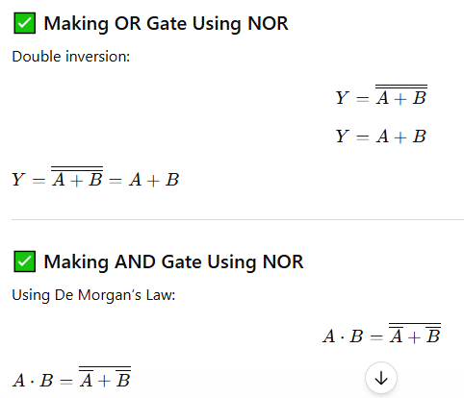

🔷 K-Map (Karnaugh Map) A to Z

📘 What is K-Map?
K-Map (Karnaugh Map) is a graphical method used to simplify Boolean expressions.
It helps reduce:
- Logic gates
- Circuit complexity
- Hardware cost

🎯 Why K-Map is Used?
✅ Simplifies Boolean equations
✅ Reduces number of gates
✅ Makes circuit faster
✅ Saves cost and power

🧩 Types of K-Map
Variables | Cells
2 Variable | 4 Cells
3 Variable | 8 Cells
4 Variable | 16 Cells

🔹 2 Variable K-Map
Variables: A, B

Structure
A\B | 0 | 1
0 | m0 | m1
1 | m2 | m3

🔹 3 Variable K-Map
Variables: A, B, C
A | BC=00 | 01 | 11 | 10
0 | m0 | m1 | m3 | m2
1 | m4 | m5 | m7 | m6

🔹 4 Variable K-Map
Variables: A, B, C, D
Contains 16 cells.
Used for larger Boolean simplification.

🧠 Important Terms in K-Map

✅ Minterm
A combination where output = 1
Example:
[
F(A,B)=\Sigma(1,2,3)
]
F(A,B)=\Sigma(1,2,3)

✅ Maxterm
A combination where output = 0
Example:
[
F(A,B)=\Pi(0,2)
]
F(A,B)=\Pi(0,2)

🔷 Rules of K-Map Grouping
Groups must contain:
- 1
- 2
- 4
- 8
- 16 cells
(Always power of 2)

📌 K-Map Simplification Example

Example:
F(A,B)=\Sigma(1,2,3)
Truth table:
A | B | F
0 | 0 | 0
0 | 1 | 1
1 | 0 | 1
1 | 1 | 1
After grouping:
Simplified equation:
F = A + B
F=A+B

🔶 Advantages of K-Map
✅ Easy simplification
✅ Saves hardware
✅ Reduces gate usage
✅ Faster digital circuit design

🔴 Limitations of K-Map
❌ Difficult for more than 5 variables
❌ Manual process
❌ Time-consuming for large circuits

📚 Final Revision Summary

Logic Gates
- AND → All inputs true
- OR → Any input true
- NOT → Reverse
- NAND → Opposite AND
- NOR → Opposite OR
- XOR → Inputs different
- XNOR → Inputs same

K-Map
- Used for Boolean simplification
- Uses grouping method
- Reduces circuit complexity
- Based on minterms and maxterms

